**Abstract Data Type : emp_type() and cal_sal():-**

**SQL Query:**

create type emp as object(

eid number,

ename varchar2(30),

emp_addr varchar2(10),

doj date,

salary number,

MEMBER Function cal_sal Return number

)not final;

create type body emp as

member function cal_sal return number is

begin

return salary;

end;

end;

create table employee of emp;

insert into employee values(emp(101,'Onkar','Talere','12-May-2020',200000));

insert into employee values(emp(102,'Adi','Tale','12-May-2010',22300));

insert into employee values(emp(103,'Om','kale','12-May-2022',2034200));

insert into employee values(emp(104,'Raju','Goa','12-May-2012',2000));

insert into employee values(emp(105,'Pandu','Pune','12-May-2000',202300));

select * from employee;

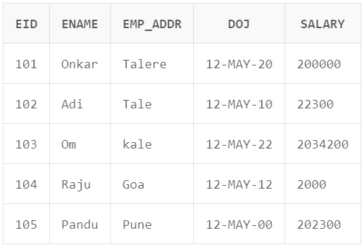

select e.cal_sal() from employee e;

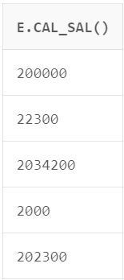

select e.ename , e.cal_sal() from employee e;

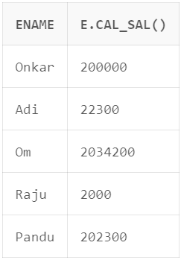

create type eng under emp

(

eng_type varchar2(10),

Member function emp_type return varchar2

);

create type body eng as

Member function emp_type return varchar2 is

Begin

return 'Engineer';

end;

end;

create table engineer of eng;

insert into engineer values(1,'Onkar','Goa','22-Dec-2008',30000,'Sr');

insert into engineer values(2,'Swapnali','Kolhapur','2-Dec-2008',30000,'Sr');

insert into engineer values(3,'Aditya','Goa','22-May-2008',30000,'Sr');

insert into engineer values(4,'Pandu','Dubai','22-Dec-2008',30000,'Sr');

insert into engineer values(5,'Sneha','Goa','22-Jun-2008',30000,'Sr');

select * from engineer;

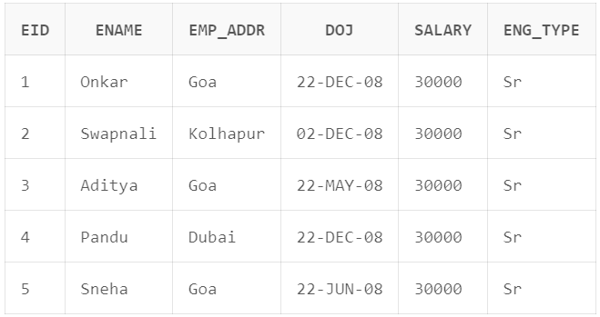

select e.cal_sal() from engineer e;

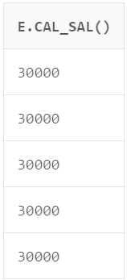

select e.ename , e.cal_sal() from engineer e;

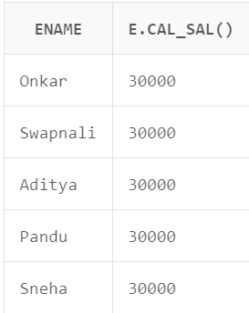

select e.emp_type() from engineer e;

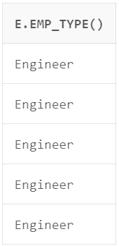

select e.ename , e.emp_type() from engineer e;

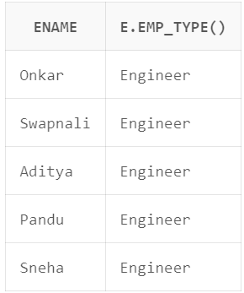

select e.ename , e.emp_type() , e.cal_sal() from engineer e;

